In this Issue:

Reflections (cont) …...P 2

Announcements ....P 2-4

Outreach Report…. P 4-5

Sea Breeze School
News …….….….…… P 5

Interim Editor:
CD & S. Rowsell

The Ambrosian

The Monthly Newsletter of St. Ambrose Episcopal Church

900 Edgewater Blvd, Foster City, California 94404

February

2016

Edition

Individual Highlights:
Inside Story 2
Inside Story 3
Inside Story 4
Inside Story 5
Inside Story 6
Inside Story 7
Last Story 8
Special Interest Articles:

• Add a highlight or your point of interest here.

• Add a highlight or your point of interest here.

• Add a highlight or your point of interest here.

Dear Members and Friends of St. Ambrose Episcopal Church,
Aloha! The rhythms of the church are not the rhythms of society today. In February our society celebrates “Super Bowl Sunday” on February 7th, Chinese New Year on February 8th, Valentine’s Day on February 14th, Presidents’ Day on February 15th. However, the church organizes its time around the celebrations of Christmas and Easter. As we move the Season after the Epiphany and to the Season of Lent, we move toward the cross of Good Friday before we celebrate the Resurrection of Easter.

However, before we enter the Season of Lent, we have two events here at St. Ambrose. Reena Davis has organized a movie night, on Friday, February 5th from 7 pm in the Parish Hall. The movie is the animated film, Tangled, especially appropriate for families with children. Lizz Klammer is organizing our “Mardi Gras” celebration following the 10 am service on Sunday, February 7th.

In February the Season of Lent begins with Ash Wednesday on February 10th. On that day we will begin our Lenten discipline by celebrating the Holy Eucharist with the imposition of ashes at 12:10 pm and 7:30 pm. This service is a solemn reminder that “we are dust and to dust we shall return.” In preparation you are invited to bring your palm crosses for the ashes by Sunday, February 7th.

As we ponder our mortality and the direction of our lives during the Sundays in Lent our Lenten Program this year will be based upon a workshop I participated in last fall, “Called to Transformation, Asset-Based Community Development Facilitator training.” During the Lenten program we will learn some of the basics about Asset-Based Community Development (ABCD) and explore how we might apply it to our personal lives and life as a congregation in our community. ABCD helps people and communities to connect to one another and come up with creative responses to challenges. The program will be held on Sundays, February 14th, 28th and March 6th and 13th from 11:45 a.m. to 1:00 p.m. The program will be preceded by a light lunch of soup, salad and bread. And thanks to Warren Wong and Shelley Keefe who have been baking bread for communion, we will also have bread for our Lenten lunches.

Reflections from our Rector

On Sunday, February 21st, the Rev. Elizabeth DeRuff will speak to the congregation at 11:45 a.m. about the heirloom flour we have been using to make our communion bread. She is an Agricultural Chaplain working to strengthen the relationship between churches and our food and farm systems. Commissioned by the National Episcopal Church she authored the Study, “Stories of Food and Farm Ministries”. Currently she directs the first wheat CSA (community supported agriculture) in the Episcopal Church, partnering with The Bishops’ Ranch in Healdsburg, CA. In the summer of 2015, she sourced local, heirloom, organic communion bread for the 78th Episcopal General Convention in Salt Lake City.

On Friday, February 19th from 6:00 p.m., to 10:00 p.m. the Foster City Chinese American Association will be celebrating Chinese New Year’s here at St. Ambrose. We are invited to celebrate with them.

Also, we will be welcoming Father Jay Watan back from his active duty at Fort Jackson, South Carolina on February 7th. I am thankful to Lizz Klammer who filled in for him with the youth ministry and the Rev. Anna Lange-Soto who led the school chapels in his absence. We will also welcome back my wife, the Rev. Karen Swanson on February 7th as our guest preacher. She had been serving as Interim Rector at All Saints, San Leandro and as a supply priest at St. James, Fremont.

Finally, as we live in these “two worlds of meaning” at the same time, I hope we will continue to be nurtured and guided by our faith in Jesus the Christ our Lord.

Yours,

David Y. Ota, Rector

Thanks
- Thanks to everyone who assisted with the Memorial Service for Merilyn Vosburg.
- Thanks to the Rev. Anna Lange-Soto who served as Chaplain to the School during Father Jay’s absence.
- Thanks to Lizz Klammer who worked with youth ministry during Father Jay’s absence.
- Thanks to Jim Neubert, Sr. Warden, Shelley Keefe, Treasurer and Warren Wong who have completed a three-year term on the Vestry at the Annual Meeting.

May Her Soul and the Souls of All the Departed Rest in Peace
Grace Belsky passed away quietly at Yesteryear House on Monday morning, January 25th. Grace was a long-time member who served on the Altar Guild, loved to arrange flowers, was an avid reader, and an engaging conversationalist with a good sense of humor. She lived to be 105 years old. She is survived by her daughter Grace Rosenberg, grandchildren and great-grandchildren. The Memorial Eucharist has yet to be scheduled. May her soul and the souls of all the departed rest in peace.

Movie Night at St. Ambrose
What: We are starting the year with yet another movie. Let’s meetup on Friday - February 5th, 2016 at 7:00 p.m. to watch a fun-filled animated movie called 'Tangled' over a light potluck dinner. Spread the message to all you know as this movie is a real entertainer for all ages.

Plot Summary of 'Tangled':
Disney presents a new twist on one of the most hilarious and hair-raising tales ever told. Your whole family will get tangled up in the fun, excitement of this magical motion picture. When the kingdom’s most wanted and most charming bandit Flynn Rider hides in a mysterious tower, the last thing he expects to find is Rapunzel, a spirited teen with an unlikely superpower 70 feet of magical golden hair! Together, the unlikely duo sets off on a fantastic journey filled with surprising heroes, laughter and suspense. Let your hair down and get ready to cheer for Tangled.

When: Friday- February 5th, 2016 at 7:00 p.m.

Where: St. Ambrose Parish Hall

Signup sheet for finger food potluck will be available in the parish hall, so please sign up and write down the tasty food you want to share with all.

For more information, please contact Reena Davis at reena.davis@gmail.com.

Saturday Evening Worship continues
Our Saturday Evening Worship this month will be held on February 6th and 20th at 5:30 p.m. It is a worship service that children can participate in more easily than the longer worship service at 8 am or 10 am on Sundays. If you are unable to worship on a Sunday, consider coming on Saturday evening.

Study Groups in February
The Monday Book Study group meets in the foyer on February 1st, 8th, 22nd and 29th from
12:45 – 2:00 p.m. They continue to read the section, “Resting in John’s Glorious Garden,” in the book, The Hidden Power of the Gospels.

The Tuesday evening Bible Study group meets on February 9th and 23rd in the home Warren and Nellie Wong at 7:00 p.m.

The Wednesday evening Bible Study group meets on February 3rd and 17th in the foyer at
7:30 p.m. They are now reading the epistles of the Apostle Paul beginning with 1 Thessalonians.

Each of the study groups is open and newcomers are invited to join.

Mark Your Calendars
- Monday Book Study: Mondays, February 1st, 8th, 22nd and 29th, 12:45 pm, Foyer
- St. Ambrose Sea Breeze School Open House: Tuesday, February 2nd, 6:30 p.m.
- Tuesday Bible Study: Tuesdays, February 9th and 23rd, 7:00 p.m., Wong’s home
- Wednesday Bible Study: Wednesdays, February 3rd and 17th, 7:30 p.m., Foyer
- Choir Practice: Thursdays, February 4th, 11th, 18th and 25th, 7:30 p.m., Chapel
- Movie Night: Friday, February 5th, 7:00 p.m., Parish Hall
- Saturday Evening Holy Eucharist: Saturdays, February 6th and 20th, 5:30 p.m., Chapel
- Mardi Gras Luncheon: Sunday, February 7th, 11:20 a.m., Parish Hall
- Lenten Lunches: Sundays, February 14th, 28th, and March 6th and 13th, 11:15 a.m., Parish Hall
- Lenten Program on Asset Based Community Development: Sundays, February 14, 28, and March 6th and 13th, 11:45 a.m., Parish Hall
- Office Closed for President’s Day Holiday: Monday, February 15th
- School Board Meeting: Tuesday, February 16th, 7:00 p.m., Parish Hall
- Foster City Chinese American Association Chinese New Year Celebration: Friday, February 19th, 6:00 p.m., Chapel, Parish Hall, Kitchen and Room 1
- Chili Cook-Off: Sunday, February 21st, 11:15 a.m., Parish Hall
- What’s Up With Wheat and the Rev. Elizabeth DeRuff: Sunday, February 21st, 12 Noon, Parish Hall
- Vestry Meeting: Tuesday, February 23rd, 7:00 p.m., Parish Hall

Outreach Report - by Steve Yuen
We normally spend the first half of January recuperating from the activities--and excesses--of the previous two months, but Outreach volunteers had to defer their break for a week.

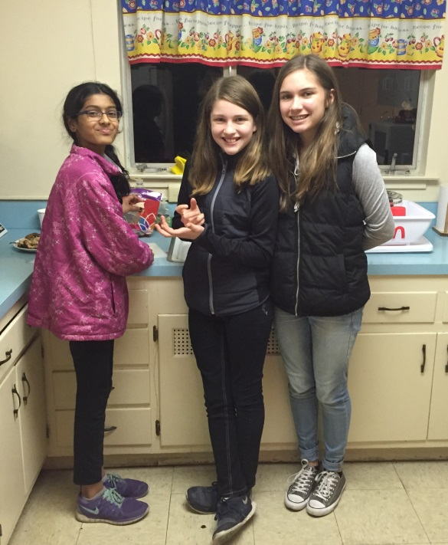
Home and Hope: On January 5th and 7th we made dinner for four (4) families at Hope Evangelical Lutheran Church in San Mateo. On Tuesday night Diane Robertson spent hours baking a 9-lb. roast ham, and on Thursday Jill Schwab put together a lavish spread of meat loaf with homemade gravy. Our St. Ambrose cooks are expert at making comfort dishes to see us through the cold winter nights!

Home and Hope (homeandhope.net) provides temporary shelter for families who are faced with unemployment, family breakup, loss of their house, and other crises. The families are finding it very difficult to be placed in affordable housing; one father is exhausted from working two jobs (he sleeps from 2:30 to 6 a.m.), but two-bedroom Peninsula apartments start at $2,500 and will be a financial reach for any of the four families.

We listened but didn't say much: as volunteers our role is not to offer advice, personal help outside of Home and Hope, and especially opinions but a sympathetic ear and, of course, food.

One encouraging sign for St. Ambrose Outreach is that new people are volunteering to replace the elder generation who can no longer drive, or even cook. In addition to making a sumptuous salad, June Kudzia folded origami birds to add a touch of class to the table settings. Rob Richards brought his daughters Kendall and Danielle with their friend Riya; it took our young carvers 15 minutes to slice up a chicken, but we all had to learn something, right? Thanks also go to Susan Yates, Liva Neyroud, and Jody Tate for potatoes, dessert, and vegetables. The volunteers—and perhaps the guests, too—had their best meals of the week.

Having overnight duty, Steve Yuen rolled out his sleeping bag. It was in the 40's outside--cold by California standards--but there were plenty of warm feelings to go around.

Our next Home and Hope dinners will be on April 19th and 21st. Even if you cannot attend, perhaps you can make a dish! We will post the sign-up sheets in the Parish Hall by mid-March. If you have any questions, please contact Steve Yuen (341-1966, stevebyuen@aol.com)

Sandwiches on Sunday (SOS): We will have a report on our January 31st outing in next month’s newsletter. If you have any questions about SOS, please contact Rob Richards (rob.richards@tensorlabs.com, 577-8924).

Sea Breeze School News
With the holidays behind us, everyone has returned to school and settled back into routines.
January and February are very busy months for us, and Wendy Walker, the school Registrar, has been busy preparing for fall registration that begins on February 3rd. If you know of anybody that is looking for a school for their child, please have them contact the office. Classes fill up very fast and we anticipate full enrollment once again next year.

As the office works on registration, the classrooms are busy with many different activities this month. They will recognize the Lunar New Year with celebrations throughout the month; they will make valentines to share with friends and families and Dr. Lee the pediatric dentist will come to talk about the importance of dental health.

The After School program is going strong and the children continue to enjoy their music appreciation class with Maureen Fromme. Homework can be a stressful time for the children and having a friendly homework buddy is always a comfort. We would love more volunteers from the church to help with our homework club, and if you have some spare time and would like to volunteer, please stop by the office and let us know.

School will be closed on Monday February 15th 2016 in observance of President’s Day.
Have a wonderful month!

